**____________________________________________**

**COVID-19 pandemic and regional growth spillovers in Indonesia:**

**A spatial econometric approach**

Harry Agintaa · Ragdad Cani Mirantib · Carlos Mendezc

**Abstract**

This study aims to investigate the impacts of the virus outbreak on regional economic growth. In doing so, we first we define a spatial connectivity structure across the provinces of Indonesia before formally implement the appropriate spatial econometric model. Our findings indicate the significance of spatial spillovers of “shocks” on provincial economic growth in the period of pandemic as opposed to non-significant spatial effect prior the pandemic.

Keywords COVID-19 · pandemic · regional · Indonesia

JEL Classifications C21 · O47 · R10 · R11

___________________________

a Graduate School of International Development, Nagoya University, JAPAN.

E-mail: [aginta.harry@c.mbox.nagoya-u.ac.jp](mailto:aginta.harry@c.mbox.nagoya-u.ac.jp)

b Graduate School of International Development, Nagoya University, JAPAN.

E-mail: [miranti.ragdad.cani@g.mbox.nagoya-u.ac.jp](mailto:miranti.ragdad.cani@g.mbox.nagoya-u.ac.jp)

c Graduate School of International Development, Nagoya University, JAPAN.

E-mail: [carlos@gsid.nagoya-u.ac.jp](mailto:carlos@gsid.nagoya-u.ac.jp)

**Introduction**

Initially detected in Wuhan, China in December 2019, the outbreak of novel coronavirus COVID-19 has attracted worldwide attention. According to World Health Organization (WHO), the first detected case outside of China was reported in Thailand on 13 January 2020 (WHO, 2020a). Thereafter, the number of infected people around the world started to show an explosive trend. Referring to the Situation Report of WHO, by the end of January 2020, the disease had infected 9,826 people globally, where 106 people were situated in 19 countries outside China (WHO, 2020b). By the end of June 2020, the same report had announced more than 10 million confirmed cases and more than 500,000 deaths (WHO, 2020c).

To limit the massive spread of the virus, more than 100 countries worldwide had implemented lockdown by the end of March 2020, either a full or partial lockdown (BBC, 2020). As lockdown policy massively instituted around the world, people’s activities had been greatly reduced, including economic and business. Several ideas explain how the pandemic may affect economic activities. A report from Asian Development Bank (ADB, 2020) mentions that COVID-19 outbreak will negatively affect economic activity via multiple channels: a sharp decline in domestic consumption, and possibly investment if views on future business activity is affected; shrinking in tourism and business travel; cross-sector and cross-country spillovers from slowing demand through trade and production linkages; supply-side disruptions to production and trade; and effects on health such as increased disease and mortality as well as shifts in health care spending.

Economists acknowledge these multiple channels of how COVID-19 pandemic reduce economic activities as so-called ‘supply’ and ‘demand’ shocks (Baldwin and Weder di Mauro, 2020). Hausmann (2020) argues the economic impact of COVID-19 is mainly in the forms of negative supply shock stemming from reduction in production capacity. When workers are infected, firms have to limit the contact between workers and if needed, stop the production temporarily. Inoue and Todo (2020) estimate that shutting down firms in Tokyo would result in an 86% reduction in output throughout Japan within one month. If the situation lasts for more than what expected, the supply shock would most likely lead to a demand shock (del Rio-Chanona et al., 2020; Guerrieri et al., 2020). On the other hand, the implementation of mitigation measures such as social distancing by governments and public health authorities in many countries has also led consumers to reduce their consumption, in particular on various services involving frequent physical contact such as restaurants, airlines, and tourism. As the workers in these sectors face significant income reduction due to lower sales, their spending on other goods and services would also decrease, leading to a shrinking in demand for goods and services across many economic sectors (Gourinchas, 2020). Furthermore, the pandemic has also increased uncertainty on future economic prospects. This eventually causes greater negative demand shock stemming from diminished consumption on durable goods and investment.

Since the pandemic is happening across the globe these‘supply’ and ‘demand’ shocks shall put the globalyat risksince the negative economic impact of the pandemic is spreading Taking into account these potential devastating impacts of COVID-19 on economy, in its World Economic Outlook (WEO) Update, June 2020, the International Monetary Fund (IMF, 2020) mentions that global growth in 2020 is projected at –4.9%, 1.9 percentage points below its April forecast, indicating that the pandemic has had a more negative impact on activity in the first half of 2020 than anticipated.

In Indonesia, the first COVID-19 infection was identified and announced in early March 2020. As of 1 July 2020, the number of confirmed infected people in the country had reached close to 57,770, with 2,934 deaths (WHO 2020d). Worse still, it is predicted that total confirmed deaths in Indonesia by 1 November 2020 would reach more than 12,800 (covid19-projections.com 2020). Like elsewhere in the world, the economic impact of COVID-19 in Indonesia is significant. The government’s latest 2020 Gross Domestic Product (GDP) forecast is a range between 1.1% contraction to 0.2% growth, down from 2019’s 5% expansion, due to the fallout of the coronavirus pandemic (https://jp.reuters.com/article/indonesia-politics-economy-gdp-idUSJ9N2C2033). A double hit scenario proposed by the OECD (OECD 2020) projects that the Indonesian economic growth rate could contract to –3.8%.

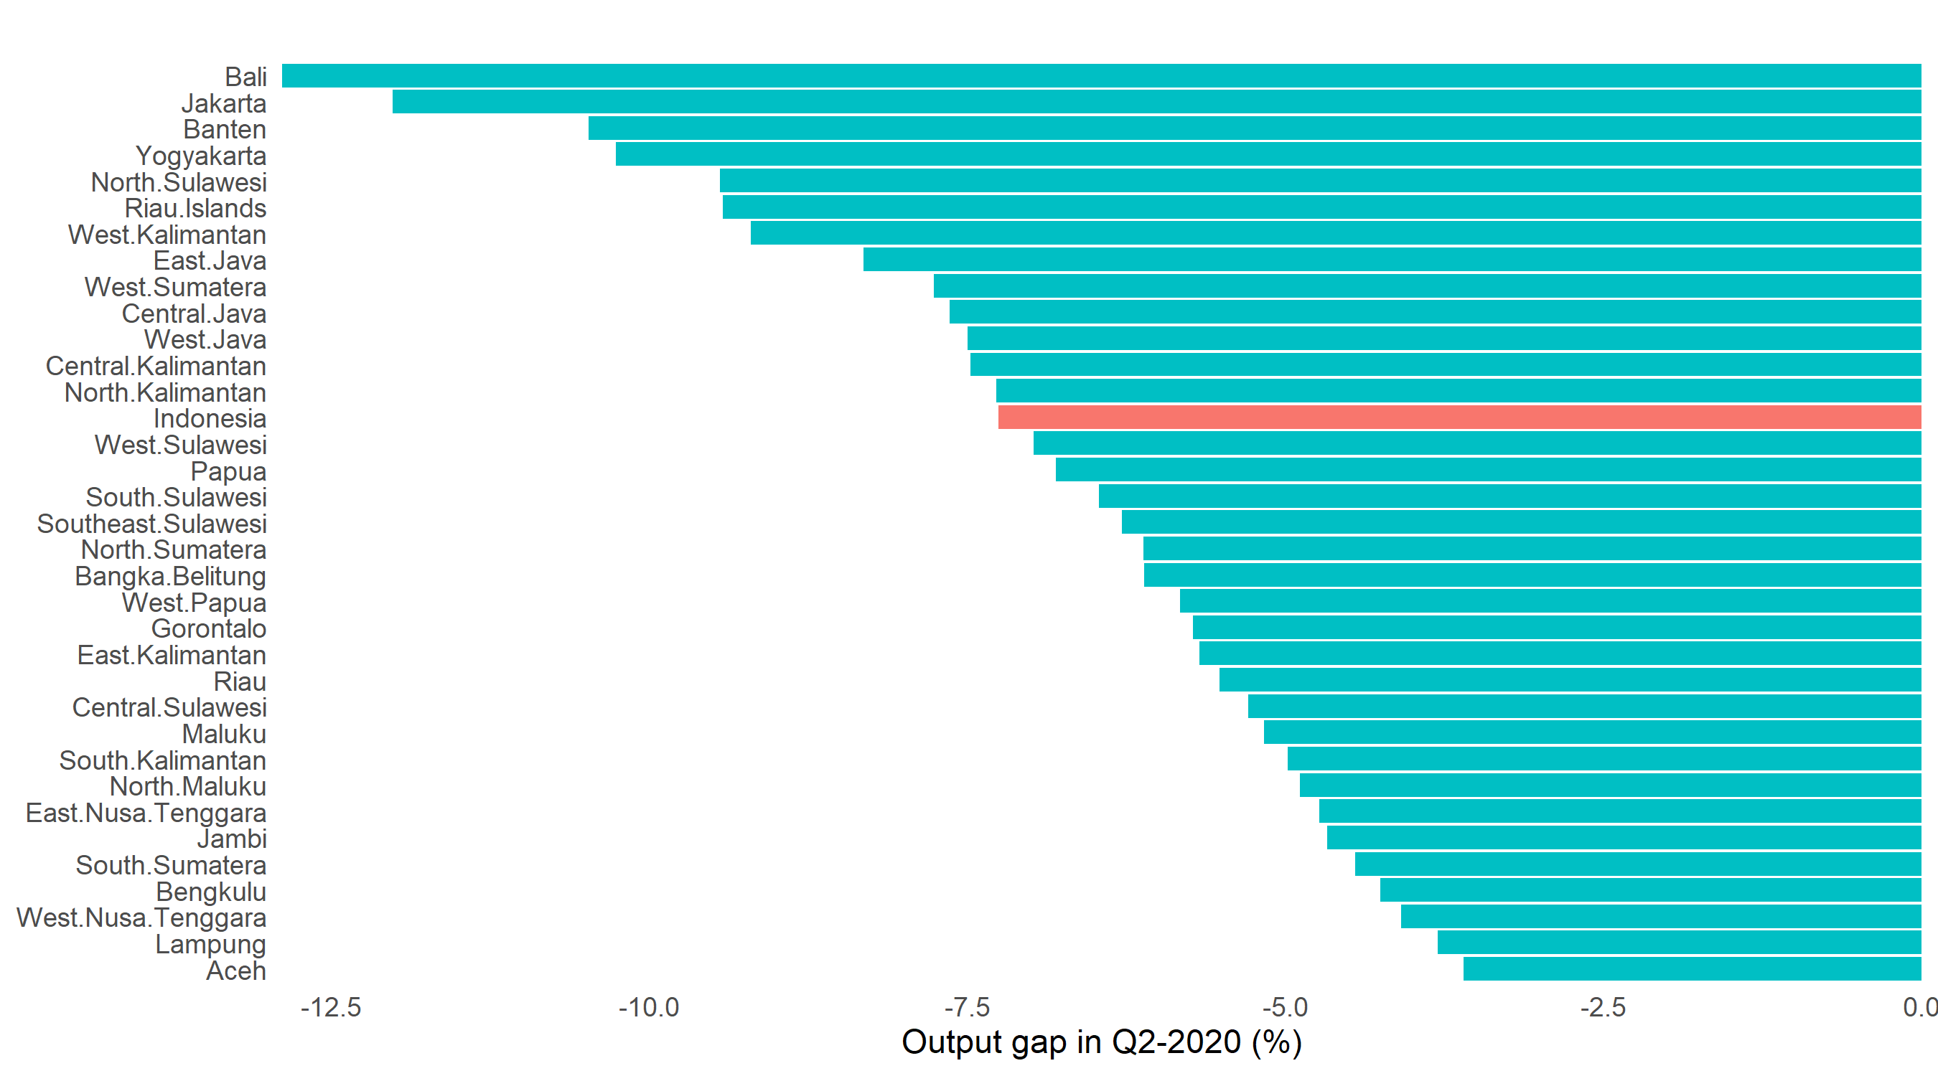

Figure 1. Output gap by province, 2020:Q2

The slowing economic activities in Indonesia has been reflected in the 2020 first semester economic performance. Figure 1 shows the impact of COVID-19 outbreak on national and regional GDP in Indonesia during 2020:Q2 measured in output gap.[1] At the national level, the pandemic had trimmed economic capacity by around 7.5% (see the red bar in Figure 1). In other words, under the implementation of large-scale social restrictions policy (Pembatasan Sosial Berskala Besar - PSBB) in many regions, the nation’s economy worked around 92.5% of its capacity. At the provincial level, although vary in magnitude, all provinces exhibited negative output gap, reflecting the depletion in economic capacity. Tourism and services driven regions like Bali, Jakarta and Banten are provinces with the highest negative output gap (see the first three top bars in Figure 1).

Analyzing regional growth dynamics across Indonesian provinces by incorporating the impacts of COVID-19 pandemic is relevant due to the unique feature embedded in the country’s regional growth experience. On one hand, as shown in Figure 1, the impacts of COVID-19 on provincial economic performance are different in magnitude owing to heterogeneity in socio-economic structures across provinces. On the other hand, according to the evidence that has been documented by some researchers, spatial spillover effect plays important role in affecting regional economic outcomes (McCulloch and Sjahrir, 2008; Suphannachart and Resosudarmo, 2009; Day and Lewis, 2013).

Departing from the background discussed above, this paper attempts to analyze how the pandemic affects the economic growth across provinces in Indonesia by incorporating the regional heterogeneity and spatial spillover effect. In the absence of adequate number of similar studies available so far, the facts and results revealed in this paper would help to bring new insights in understanding how the spread of COVID-19 affects regional economic growth in Indonesia when the geographical proximity between provinces is accounted for. In short, our estimates from spatial econometric models show that the provincial growth in the pandemic period is affected by the spillover of shocks in the surrounding regions.

The rest of this paper is organized as follows. Section 2 exposes some related literature and Section 3 discusses recent development on COVID-19 cases in Indonesian regions and the latest figure of regional economic growth. In Section 4 we discuss data and methodology. Section 5 presents the results and discussion, and finally Section 6 concludes the paper.

**LITERATURE REVIEW**

Indonesia consists of hundreds of ethnic groups with many different cultures and religious beliefs spreading throughout the world’s largest archipelago. Its multidimensional diversity across regions makes Indonesia as one of countries that is attractive for applying spatial analysis. In economic field, analysis using spatial analysis is of particular relevant for Indonesia given its heterogeneity in regional economic structure and regional data availability (Islam and Khan, 1986). This section exposes previous literature that emphasize the role of spatial spillover effect and regional heterogeneity in Indonesia’s regional growth dynamics.

A collection of studies has been implemented to estimate the spillover effects of economic performance across regions in Indonesia. By exploiting a large district-level dataset covering education, population, cultural, economic, and infrastructure variables, McCulloch and Sjahrir (2008) attempt to explain the spatial factor that affect growth when controlling for other variables. Their findings suggest that spatial spillover matters in regional growth dynamics, that is, districts surrounded by the fast-growing neighbors tend to grow faster. Another study is conducted by Suphannachart and Resosudarmo (2009) to analyze the spatial spillover in poverty incidence in Sumatra. Their estimation results present two appealing outcomes; *first*, the poverty incidence in Sumatra is spatially dependent, and *second*, the spatial spillover from neighboring regions is prevalent, that is, the poverty in a district is influenced by the poverty incidence in the neighboring districts. The study of Day and Lewis (2013) also shows the evidence of spatial spillover effects across Indonesian districts. Instead of focusing merely on growth spillover, they analyze spatial spillovers of several different factors that contribute to economic development. Their findings suggest that, in addition to income, the influence of neighbors also includes demographics, human capital and infrastructure component of economic development.

Several authors have also analyzed the impacts of economic shocks on regional economy in Indonesia by highlighting the role of regional heterogeneity. Ridhwan and Bary (2018) develop structural macroeconomic models for 32 provinces to estimate the regional impacts of four types of shocks, both from domestic and external sources: credit volumes, administered price inflation, world output and exchange rate. Their findings show systematic differential responses to the common shocks on both provincial output and inflation. They further point out that provinces in Java island appear to be more resilient relative to the off-Java regions, thanks to its more developed and diversified economy. With respect to policy shock, Ridhwan et al (2014) and Wijoseno (2016) apply Vector Autoregression (VAR) framework and show evidence in asymmetric effect of uniform change in monetary policy rate on provincial output. Their further investigation reveals that province’s economic structure such as bank loans and deposits, share of manufacturing in regional output, firm size, trade openness, and housing prices appear to be the determinants of differential reginal effects of monetary policy, consistent with the theoretical foundation of monetary policy transmission.

**THE PANDEMIC AND REGIONAL ECONOMIC PERFORMANCE IN Q2-2020**

Before formally analyzing the impacts of COVID-19 cases on regional economic growth, it is necessary to document some recent development on the number of COVID-19 cases and economic indicators across Indonesian provinces. In Figure 2 we present the charts of COVID-19 cases and the selected economic variables across provinces in 2020:Q2. This is useful to understand how the pandemic affects economic activities contemporaneously. Panel (a) plots the change in number of COVID-19 cumulative cases (per 100,000 population) from March to June 2020. The highest increase of number of cases is recorded in Jakarta, the capital of Indonesia (100.3), followed by South Kalimantan (72.9), and North Maluku (56.85), while Aceh province records the lowest increase in number of cases per 100,000 population (we computed the change in number of COVID-19 cumulative cases based on the daily data available at https:// kawalCOVID19.id.).

As seen in panel (b), most of provinces (32 out of 34) recorded negative growth in 2020:Q2 (yoy, %), where provinces in Java-Bali region are the worst performers. The economic growth of Bali, Jakarta, Banten provinces are -10.98%, -8.22%, and -7.4% (year-on-year) respectively. On the other hand, two easternmost provinces, West Papua and Papua, were able to maintain positive economic growth of 0.53% and 4.52% respectively. We also utilize the COVID-19 Community Mobility Index from Google to capture the effects of pandemic on people mobility. From panel (c), one may observe that Bali, Maluku and Jakarta are the provinces where mobility reduced the most relative to the baseline.[2] We also document the number of people who lose their jobs as the impacts of COVID-19 pandemic, plotted in panel (d). Similar to the impacts on economic growth, provinces in the Java region report the highest number of people who had lost their jobs due to pandemic. West Java province suffers the most with around 340,000 people reporting lost their jobs from March to June 2020. Next, Jakarta, Central Java and East Java are the other provinces that record high numbers of jobs losses during the same period (we received the data from the Ministry of Manpower).

|  |
| --- |
| (a) Change in number of cases |
| (b) GDP growth in Q2-2020 |
| (c) Change in people’s mobility |

|  |
| --- |
| (d) Number of people who lose jobs |
| (e) Correlation between selected variables. Significant correlation at 5% is marked with star. |

Figure 2. COVID-19 cases and the development of some main economic variables



Lastly, panel (e) show the correlation among the indicators plotted in Figure 2.[3] Several interesting points can be highlighted. First, people’s mobility is significantly having negative correlation with the change in number of COVID-19 cases and the share of TAS (Transportation, Accommodation and Services) in GDP. This means that mobility decreases at the larger rate in provinces with higher COVID-19 cases and TAS share in GDP. Second, GDP growth is more connected to number of jobs loss and TAS share in GDP. Third, in addition to people’s mobility, the change in number of COVID-19 case is also significantly correlated with the share of TAS in GDP. Overall, the plot is useful to explain how the current state in one variable is affecting the others. In particular, the current condition of economic structure has significant correlation with three out of four other variables; it is negatively correlated both with GDP growth and people’s mobility while has positive correlation with the change in number of cases. Since the number of infected people is higher in provinces with higher TAS share in GDP (the positive correlation), local governments implemented large-scale social restrictions (PSBB) policy to minimize contacts among people, such as schools’ closure, work-from-home, restrictions on religious congregations and even closing of houses of worship. As the results, people’s mobility decreased, and the reduction in people’s mobility decelerates economic activities (this explains the negative correlation).[4]

**Data and Methodology**

We use data available at https:// kawalCOVID19.id. This data is used to evaluate the spatial dependence of COVID-19 infection cases across Indonesian provinces. The original data contains daily cumulative cases in 34 provinces. We transformed the daily data into a ratio of monthly cumulative case per 100.000 population and used it as the final data.

We use quarterly provincial real GDP data published by Indonesian Central Statistics Bureau to capture real economic variable. The final form of GDP data used is the annual GDP growth rate (yoy, %). We utilize this dataset to estimate the spatial dependence of economic impacts of COVID-19 across provinces. The summary statistics of our regression variables is presented in Table 1.

Table 1. Summary Statistics of GDP and GDP growth rate in both periods

|  |  |  |  |  |  |  |  |
| --- | --- | --- | --- | --- | --- | --- | --- |
| Variables | Mean | Std.Dev | Min | 25% | Median | 75% | Max |
| GDP 2015:Q1 | 64300000 | 90900000 | 4922250 | 15064409 | 27500000 | 60660602 | 351000000 |
| GDP 2019:Q4 | 83100000 | 119000000 | 6869000 | 20608658 | 34600000 | 81776676 | 471000000 |
| GDP 2019:Q1 | 78500000 | 113000000 | 6473000 | 17330444 | 31400000 | 81776676 | 446000000 |
| GDP 2020:Q2 | 76400000 | 108000000 | 6581357 | 17860654 | 32300000 | 79259316 | 415000000 |
| GDP Growth 2015:Q1 – 2019:Q4 | 0.014 | 0.004 | 0.006 | 0.012 | 0.013 | 0.303 | 0.03 |
| (without pandemic period) |  |  |  |  |  |  |  |
| GDP Growth 2019:Q1 – 2020:Q2 | 0.001 | 0.012 | -0.014 | -0.004 | 0.001 | 0.030 | 0.005 |
| (with pandemic period) |  |  |  |  |  |  |  |

Note: GDP value on the table above is in Million Rupiah

To carry out a spatial analysis, we first define a spatial connectivity structure across the provinces of Indonesia. In the literature, there are multiple criteria to define that structure. The most popular are spatial contiguity, spatial distance, and k-nearest neighbors. In this paper, we implement a generalized version of spatial contiguity based on the estimation of Thiessen polygons (Anselin and Rey, 2014). We use GIS data to define the centroid of each province and construct the Thiessen polygons accordingly as shown in Figure A1 of Appendix. From the estimated polygons, we estimate spatial connectivity based on the contiguity in the polygon of provinces (see Figure A2 of Appendix). Specifically, two polygons (or provinces) are neighbors when they share a common border or an edge. The estimation of Thiessen polygons allows us to define a spatial connectivity structure based on individual areas of influence around geographical locations. To facilitate visual interpretation, Figure 3 shows the overlap between the estimated connectivity structure and the provincial map of Indonesia.

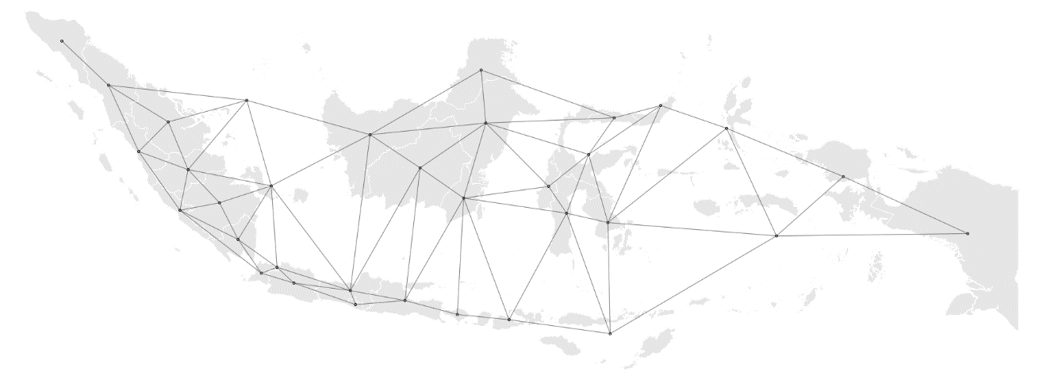

Figure 3. Spatial connectivity structure of the provinces of Indonesia

Anselin (1995) proposes way to visualize the strength and type of local spatial dependence. He uses a scatter plot to study the relationship between an attribute of a region (*x*) and the weighted average of its neighbors (**W***x*). The neighbors of every region are identified based on the previously estimated connectivity structure, which is operationalized as a weights matrix (**W**). The quadrants of the scatter plot classify the regions as hot spots (relatively high values), cold spots (relatively low values), and spatial outliers (high values surrounded by low values and vice-versa). A local indicator of spatial association (LISA), *Ii* , is computed for each region as follows:

|  |  |
| --- | --- |
|  | (1) |

where is a spatial weight that is derived from the spatial structure **W**, is the variable under study measured in region *i*, is the same variable measured in region *j*, and is the average of *x*. Following Anselin et al. (2007), statistical inference is based on a conditional permutation approach.

As the main analysis of this paper, we examine the regional growth impacts of COVID-19 pandemic by applying spatial regression framework. Basically, spatial analysis is about accounting for spillover effects derived from spatial dependence between regions. Spatial autoregressive models broaden the ordinary linear regression through permitting dependent variables in one area to be affected by dependent variables in neighboring areas, covariates from neighboring areas, and errors from neighboring areas. Anselin (1988) has firstly introduced two common models to recognize spatial dependence through spatial autoregressive models, which are Spatial Lag Model (SLM) and Spatial Error Model (SEM). It commonly consists of spatial lag model and the spatial error model. Fingleton and Lopez-Bazo (2006) also confirms that spatial dependence among growth processes of sub-national level may be caused by two types of features. The first feature is correlated with random shocks, symbolized by spatial error models, coming from neighboring regions and another one is correlated with the growth rates of neighboring regions, symbolized by spatial lag models. Lesage and Fischer (2008) also concerned attention to the issue of spatial dependence in growth regressions. The issue may come due to pecuniary externalities from neighboring regions (captured by spatial lag) or spatial autocorrelation among regression residuals (captured by spatial errors). If this issue is uncovered, it will lead to inconsistent and bias estimation because correlation between spatially lagged dependent variable ends up in model generating parameter estimates smaller or larger than the true model.



Taking the standard growth regression of Solow without augmenting with human capital and physical capital as (Mankiw. et.al, 1992) as the starting point, we follow the seminal works of Rey and Montouri (1999) by involving the role of spatial dependence across regions. The purpose of the inclusion of spatial dependence is to give intuitive comprehension that interactions among geographical neighbors can affect the outcome of the entire regional system. If those interactions are not included in Equation 2, and they are reflected as spatial dependence in the error term, then the estimates of Equation 2 can be misleading. Unaccounted spatial dependence can lead to biased or inefficient estimates of the convergence indicators.

Two most prominent specifications used in the spatial regression literature are SLM and SEM. In our analysis, we implement the cross-sectional spatial regression model. In the SLM specification, spatial dependence exhibits the actual interaction among spatial units that take place through the dependent variable. In this context, our SLM specification is as follows,

|  |  |
| --- | --- |
|  | (2) |

where **W** is the spatial weights matrix that represents the spatial structure of the data, is the spatial lag of the dependent variable, is spatial lag coefficient, is the average growth rate of the GDPduring T period (quarters) , is value of the GDP in the base (initial) year, which are Q2015:1 for the model without pandemic period and Q2019:1 for the model including pandemic period and is error term.

In the SEM specification, on the other hand, spatial dependence could represent a missing variable that embodies a spatial structure. In this context, our SEM specification is written as follows,

|  |  |
| --- | --- |
|  | (3) |

where I is a vector of ones, **W** is the spatial weights matrix, and *λ* is a spatial error coefficient.

Both spatial models are estimated through maximum likelihood estimation. To choose the best model, the measures that commonly used are through R-square, Log-Likelihood, Akaike information criterion (AIC) and Bayesian Information Criterion (BIC). In this paper, the model selection is based on Akaike information criterion (AIC) as well as the Bayesian Information Criterion (BIC). Based on those indicators, the model with the smallest value of AIC and BIC is the fittest.

**Results and discussion**

This section presents the main findings of spatial autoregressive models in evaluating how the pandemic affects the spillovers of economic growth across provinces. To be more precise, we measure how the growth in a province is affected by the growth in surrounding regions. Ideally, in our equation we should consider all necessary growth determinants explained in the standard Solow growth model featuring the Cobb-Douglas production function (Islam, 1995). However, due to data availability and time constraint, we use initial economic condition (log of GDP in 2015:Q1 for modeling the period without pandemic and log of GDP in 2019:Q1 for modeling the period with pandemic) as the proxy of growth determinants, where the economy is assumed to be in its natural condition. Thus, our model captures the spatial effects of economic growth by controlling the natural level of main growth determinants. To understand the impacts of the pandemic, the model is estimated for two different time span; from 2015:Q1 to 2019:Q4 and from 2019:Q1 to 2020:Q2. The first period represents the period without pandemic effect and the latter is referred to the period with pandemic effect.

One important assumption in spatial autoregressive model is the existence of spatial dependence in residuals. Thus, before estimating the spatial autoregressive model, we conducted spatial dependence test by applying Moran’s I test. Table 2 presents the results of the test between two periods; the period without pandemic effect (Column 2) and with pandemic effect (Column 3). The result suggests to accept the hypothesis that residuals in both periods are independent and identically distributed (i.i.d.). This indicates that the residual factors in the economic growth equation are spatially independent during COVID-19 period in both periods, implying the inexistence of spatial autocorrelation among residuals in both models. However, since our spatial autocorrelation analysis through Moran’s I statistics suggest that the existence of significant spatial dependence of our variables among regions, the importance of including spatial variable in the model, in this case, spatial lag and spatial error, could be considered in our analysis.

Table 2. Spatial dependence test in the residuals

|  |  |  |  |  |
| --- | --- | --- | --- | --- |
| Variables | GDP growth rate | | GDP growth rate | |
| 2015:Q1 – 2019:Q4 | | 2019:Q1 – 2020:Q2 | |
| (Without pandemic period) | | (With pandemic period) | |
| Number of observations | 34 | | 34 | |
| Moran's I Statistics in the residual | 1.48 | | 0.00 | |
| p-value | 0.22 | | 0.99 | |
| Notes: Robust standard error in parentheses. |  |  |  |  |
| *** *p* < 0.01, ** *p* < 0.05, * *p* < 0.1 |  |  |  |  |

Table 3 presents the results of spatial and non-spatial regressions of the GDP growth in pre-pandemic period and with pandemic period. All spatial regressions are estimated using maximum likelihood estimator for cross-sectional data. The table shows that both coefficient in OLS and SLM model are significant in pre-pandemic period, while only coefficient in SEM model is significant in the with pandemic period. In terms of spatial autocorrelation coefficient, which are spatial lag and spatial error coefficient, although they are not statistically significant and relatively small, they still imply the existence of spatially correlated dependent variable and error among provinces.

Table 3. Non-spatial and spatial regression of with and without inclusion of pandemic period

|  |  |  |  |  |  |  |
| --- | --- | --- | --- | --- | --- | --- |
|  | Without pandemic period | | | With pandemic period | | |
| Variables | Dependent Variable: GDP Growth of 2015:Q1 – 2019:Q4 | | | Dependent Variable: GDP Growth of 2019:Q1 – 2020:Q2 | | |
| OLS | SLM | SEM | OLS | SLM | SEM |
| Log of GDP in 2015Q1 | -0.022** | -0.022* | -0.026 | -0.005 | -0.005 | -0.006** |
|  | (0.01) | (0.012) | (0.013) | (0.010) | (0.011) | (0.011) |
| Log of GDP in 2019Q1 |  |  |  |  |  |  |
|  |  |  |  |  |  |  |
| Spatial Lag Coefficient |  | 0.253 |  |  | 0.018 |  |
|  |  | (0.235) |  |  | (0.264) |  |
| Spatial Error Coefficient |  |  | 0.318 |  |  | -0.004 |
|  |  |  | (0.235) |  |  | (0.278) |
| Constant | 0.660* | 0.586* | 0.721* | 0.100 | 0.098 | 0.101 |
|  | (0.169) | (0.216) | (0.223) | (0.167) | (0.184) | (0.189) |
| Model selection/information criteria | | | | | | |
| AIC | -70.570 | -67.653 | -68.206 | -81.104 | -77.109 | -77.105 |
| BIC | -67.518 | -61.548 | -62.100 | -78.052 | -71.004 | -70.999 |
| Notes: Robust standard error in parentheses. | |  |  |  |  |  |
| *** *p* < 0.01, ** *p* < 0.05, * *p* < 0.1 |  |  |  |  |  |  |



To be more specific, to estimate the effect of initial economic size to the economic growth in pre-pandemic period, firstly we should define our best specification model. The two significant models, OLS and SLM tend to generate similar coefficient of economic size. Comparing the two indicators of goodness of fit test, OLS model appears to be the fittest with the smallest AIC and BIC in the pre pandemic period. It is also supported by the insignificant spatial lag coefficient in our spatial regression model, indicating that the estimation process without including spatial effect would not lead to generate the bias parameter. Thus, in normal condition, the negative coefficient on the log of GDP in 2015:Q1 suggest that larger economies are affected worse from the economic downturn.Then, the results of spatial and non-spatial regressions of the economic growth in including pandemic period, where it evaluates the effect of including COVID-19 pandemic period to the regional growth dynamics. All coefficients reported in Table 3 show negative sign. However, only coefficient in SEM model is statistically significant. This significant and negative coefficient indicates that the regression residuals of a province is related to the regression residuals of neighboring provinces. The negative and significant coefficient on the log of GDP in 2019:Q1 implies that larger economies suffer more from growth declining when we include pandemic period in our period of observation. Since most of provinces with high GDP are located in Java-Bali region, the slump in economic growth during pandemic period is relatively larger in this region.

As mentioned earlier, the spatial error model assumes that the error term of province i depends on the error term of neighboring provinces on the basis of spatial weight matrix. In other words, significant spatial error coefficient reported Table 3 shows that the decline of growth in including pandemic period is affected by both province-specific shocks and other ‘spill-over’ shocks from neighboring provinces. Practically, the negative coefficient suggests that the increase of shocks of the neighboring regions tend to decrease the economic growth of a particular province.

Finally, as suggested by LeSage and Pace (2009), the estimated coefficient of SLM and SEM specification can be decomposed into direct and indirect effects to show the contribution of spatial spillovers. However, in the spatial error model, spatially correlated errors do not induce spillover effects in the covariates. Therefore, the results from this exercise lead to further research avenue to formally specify the ”shocks” (other variables unexplained in this study) and then measure their impacts on regional growth dynamics.

**Conclusion**

This study aims to investigate the impacts of the virus outbreak on regional economic growth dynamics. The results from spatial econometric models show that the provincial growth in the pandemic period is affected by the spillover of shocks in the surrounding regions.

As common in other spatial studies, we acknowledge the limitation of this study could include two following issues. First, the specification of weight matrix using contiguity of the estimated Thiessen polygons. Since there is no a single solid method that identifies a unique weight matrix reflecting the connectivity between locations, it is useful to test the models with alternative weight matrix. Second, given the availability issue and time constraints, the data used in the models is very limited to explain the complex regional growth dynamics. Therefore, future studies should incorporate more variables, including the institutional determinants of growth at a province level to obtain reliable estimates.

**REFERENCES**

ADB (2020). The Economic Impact of the COVID-19 Outbreak on Developing Asia. Asian Development Bank. [https://www.adb.org/sites/default/files/publication/571536/adb-brief-128-conomic-impact-COVID19-developing-asia.pdf](https://www.adb.org/sites/default/files/publication/571536/adb-brief-128-conomic-impact-covid19-developing-asia.pdf). Accessed: 2020-08-28.

Anselin, L. (1988). Spatial Econometrics: Methods and Models. Kluwer Academic Publisher, Dordrecht, Netherlands.

Anselin, L. (1995). Local indicators of spatial association—LISA. Geographical Analysis, 27(2):93–

115.

Anselin, L., Sridharan, S., and Gholston, S. (2007). Using exploratory spatial data analysis to leverage social indicator databases: The discovery of interesting patterns. Social Indicators Research, 82(2):287–309.

Anselin, L., and Sergio J. Rey. (2014). Modern Spatial Econometrics in Practice, a Guide to Geoda, Geodaspace and Pysal. Chicago, IL: GeoDa Press.

Baldwin, R and B Weder di Mauro (2020). Economics in the time of COVID-19: A new eBook, VoxEU.org, 6 March.

BBC (2020). Coronavirus: The world in lockdown in maps and charts. <https://www.bbc.com/news/world-52103747>. Accessed: 2020-08-25.

COVID19 projections.com (2020). COVID-19 Projections Using Machine Learning. [https://COVID19-projections.com/indonesia](https://covid19-projections.com/indonesia). Accessed: 2020-08-28.

del Rio-Chanona, R. M., Mealy, P., Pichler, A., Lafond, F., and Farmer, D. (2020). Supply and demand shocks in the COVID-19 pandemic: An industry and occupation perspective. arXiv preprint arXiv:2004.06759.

Fingleton, B. (1999). Estimates of time to economic convergence: an analysis of regions of the European Union. International Regional Science Review, 22(1):5–34.

Fingleton, B. and Lopez-Bazo, E. (2006). Empirical growth models with spatial effects. Papers in Regional Science, 85(2):177–198.

Gourinchas, P O (2020). Flattening the pandemic and recession curves, VoxEU.org, 3 June.

Guerrieri, V., Lorenzoni, G., Straub, L., and Werning, I. (2020). Macroeconomic implications of COVID-19: Can negative supply shocks cause demand shortages? Technical report, National Bureau of Economic Research.

Hausmann, R. (2020). Flattening the COVID-19 Curve in Developing Countries. Project Syndicate. [https://www.project-syndicate.org/commentary/flattening-COVID19-curve-in-developing-countries-by-ricardo-hausmann-2020-03](https://www.project-syndicate.org/commentary/flattening-covid19-curve-in-developing-countries-by-ricardo-hausmann-2020-03). Accessed: 2020-04-28.

IMF (2020). World Economic Outlook Update, June 2020. A Crisis Like No Other, An Uncertain Recovery. International Monetary Fund. <https://www.imf.org/en/Publications/WEO/Issues/2020/06/24/WEOUpdateJune2020>. Accessed: 2020-08-28.

Inoue, H. and Todo, Y. (2020). The propagation of the economic impact through supply chains: The case of a mega-city lockdown against the spread of COVID-19. Available at SSRN 3564898.

Islam, N. (1995). Growth empirics: A panel data approach. The Quarterly Journal of Economics, 110(4):1127–1170.

Islam, I. and H. Khan (1986). Spatial Patterns of Inequality and Poverty in Indonesia, Bulletin of Indonesian Economic Studies, 22(2): 80-102.

Jennifer Day & Blane Lewis (2013). Beyond univariate measurement of spatial autocorrelation: disaggregated spillover effects for Indonesia, Annals of GIS, 19:3, 169-185.

LeSage, J. and Pace, K. (2009). Introduction to Spatial Econometrics. Chapman & Hall/CRC, Boca Raton, Florida.

McCulloch, N., and B. S. Sjahrir (2008). Endowments, Location or Luck? Evaluating the Determinants of Subnational Growth in Decentralized Indonesia. World Bank Policy Research Working Paper WPS4769 1 (1): 1–34.

OECD (2020). OECD Indonesia Economic Outlook No 107 - June 2020 Double Hit Scenario. Organization for Economic Co-operation and Development. <https://stats.oecd.org/Index.aspx?QueryId=72657>. Accessed: 2020-08-29.

Rey, S. J. and Montouri, B. D. (1999). US regional income convergence: A spatial econometric perspective. Regional Studies, 33(2):143–156.

Ridhwan, M. M., & Bary, P. (2018). The regional effects of macroeconomic shocks in Indonesia. In Resilience, Crisis and Innovation Dynamics. Edward Elgar Publishing.

Ridhwan, M. M., de Groot, H. L., Rietveld, P., and Nijkamp, P. (2014). The regional impact of monetary policy in Indonesia. Growth and Change, 45(2):240–262.

Suphannachart, W., & Resosudarmo, B. P. (2009). Preliminary analysis of spatial regional growth elasticity of poverty in Sumatra.

WHO (2020a). A Statement on Novel Coronavirus in Thailand. World Health Organization. Geneva. <https://www.who.int/news-room/detail/13-01-2020-who-statement-on-novel-coronavirus-in-thailand>. Accessed: 2020-08-28.

WHO (2020b). Situation Report. World Health Organization. Geneva. <https://www.who.int/docs/default-source/coronaviruse/situation-reports/20200131-sitrep-11-ncov.pdf?sfvrsn=de7c0f7_4>. Accessed: 2020-08-25.

WHO (2020c). Situation Report. World Health Organization. Geneva. [https://www.who.int/docs/default-source/coronaviruse/20200630-COVID-19-sitrep-162.pdf?sfvrsn=e00a5466_2](https://www.who.int/docs/default-source/coronaviruse/20200630-covid-19-sitrep-162.pdf?sfvrsn=e00a5466_2). Accessed: 2020-08-25.

WHO (2020d). Situation Report, Indonesia. World Health Organization. Geneva. [https://www.who.int/docs/default-source/searo/indonesia/COVID19/who-situation-report-14.pdf?sfvrsn=39243224_2](https://www.who.int/docs/default-source/searo/indonesia/covid19/who-situation-report-14.pdf?sfvrsn=39243224_2). Accessed: 2020-08-25.

Wijoseno, A.R. (2016). Three essays on banking, monetary policy, and regional economy in Indonesia. (Unpublished doctoral dissertation). University of North Carolina, Chapel Hill.

**APPENDIX**

A1After estimating the Thiessen polygons, a spatial connectivity structure (network of connections) is defined based on the contiguity of the of the polygons (Figure A2). Specifically, two polygons (or provinces) are neighbors when they share a common border or an edge.

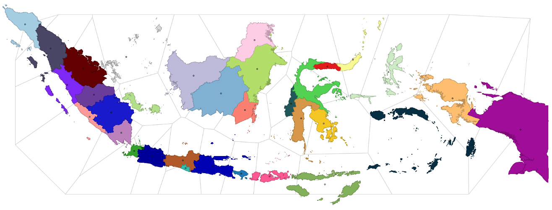

Figure A1. Indonesian provinces, centroids, and Thiessen polygons

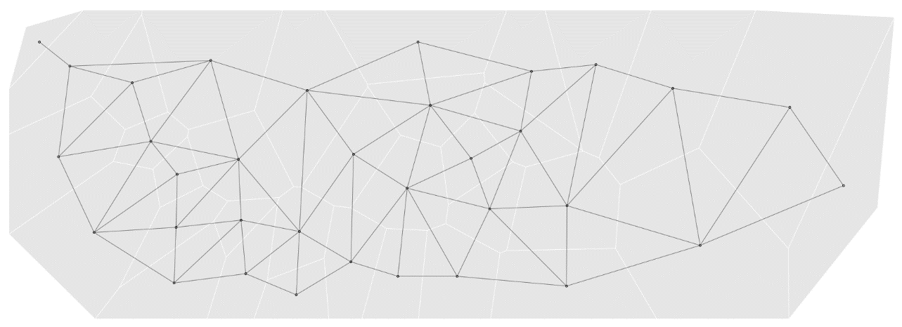

Figure A2. Centroids, Thiessen polygons, and spatial connectivity structure

1. Output gap is the gap between potential and actual output. For simplicity, we used Hodrick-Prescott (HP) filter to extract the trend of GDP data as estimate of potential output. The computed output gap is the difference between actual GDP data and its estimated trend.
2. The data shows how people to (or time spent in) categorized places change compared to baseline days. The baseline day is the median value from the 5-week period Jan 3 – Feb 6, 2020, representing a normal value for that day of the week. For further details about category of places and everything related to the data, please visit

   https://support.google. com/covid19-mobility/answer/9824897?hl=en&ref_topic=9822927.
3. We include the share of Transportation, Accommodation and Services (TAS) to GDP in addition to previous variables. In the statistics of Indonesian GDP, TAS sector includes ”Transportasi dan Pergudangan”, ”Penyediaan Akomodasi dan Makan Minum”, ”Administrasi Pemerintahan, Pertahanan dan Jaminan Sosial Wajib”, and ”Jasa Lainnya”.
4. For exploration of COVID-19 cases and its economic impacts across provinces in Indonesia, please visit [RPubs - Covid-19 pandemic and its economic impacts in Indonesia](https://rpubs.com/haginta/covid19-econ-impacts-indonesia) and [Covid-19 pandemic and its economic impacts: An interactive exploration on Indonesian provincial data (shinyapps.io)](https://haginta.shinyapps.io/Covid19_econ_impacts_reg_Indonesia/)